Monthly Performance Report – August 2026
Kestrel Ridge Wind Farm (75.6 MW)
David Chen · 07 September 2026 · KR-OPS-RPT-2026-08

1. Summary
Kestrel Ridge generated 13.0 GWh in August 2026, 3.2 % above the P50 budget of 12.6 GWh. Time-based availability was strong at 97.8 % (contract target 97.0 %). Mean hub-height wind speed was 7.2 m/s, above the long-term monthly mean of 6.9 m/s. Compared with August 2025 (12.3 GWh), output was up 0.7 GWh.
Drone blade inspection campaign completed on all 54 blades. Leading edge erosion progressed on 4 blades from Category 2 to 3; rope-access repairs are planned for May–June 2027.

2. Production and key figures
KPI | August 2026 | Budget / target | YTD 2026 | YTD budget
Net generation (GWh) | 13.0 | 12.6 | 129.6 | 133.6
Time-based availability | 97.8 % | 97.0 % | 97.0 % | 97.0 %
Capacity factor | 23.1 % | 22.4 % | 29.4 % | –
Mean wind speed at hub height (m/s) | 7.2 | 6.9 | – | –
Source: Kestrel Ridge SCADA, revenue meter at 132 kV point of connection. Budget = P50 (2024 post-construction yield assessment).
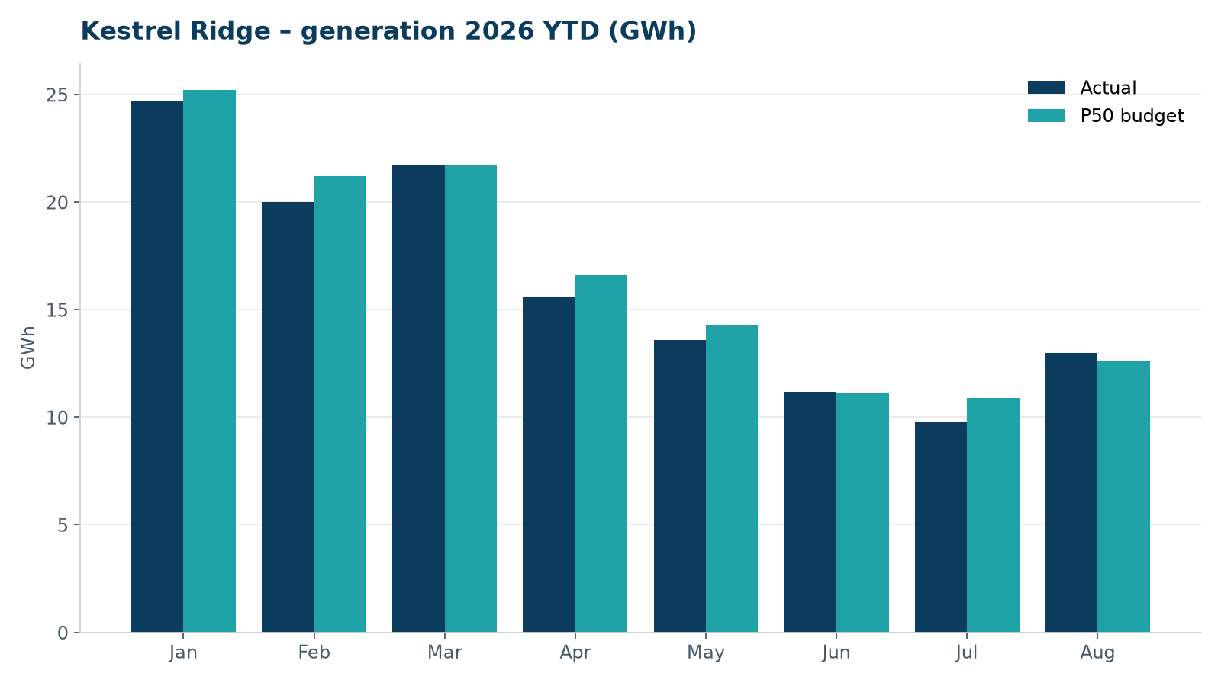
Monthly generation vs. P50 budget, 2026 year to date
Downtime events pending confirmation by Highline Wind Services.

